ECO3702: Advanced Macroeconomics Lecture Note 4

2018

Mundell Fleming Model

Policy Analysis with Mundell – Fleming Model

**Kaan Öğüt**

Eicher, Muti, Turnovsky,2009, International Economics, Routledge. Chapters, 18 and 19

Bahçeşehir unıversıty

**Policy Analysis with Mundell – Fleming Model:**

First choose the exchange rate regime in 1. Then pick the degree of capital mobility in 2. Finally, the impact of a specific policy in 3., given these assumptions (1. and 2.), will be assessed as a separate case below.

1. **Exchange Rate**

* Fixed
* Flexible

1. **Degree of Capital Mobility**

* Low Capital Mobility, Steep BP (steeper than LM)
* High Capital Mobility, Flat BP (flatter than LM)
* Perfect Capital Mobility, Horizontal BP

1. **Policy**

* Monetary Policy
* Fiscal Policy
* Exchange Rate Policy
* 

## 

## 

## Monetary Policy under Fixed Exchange Rates

## We start with the unique equilibrium for the three markets: goods market, financial markets, and foreign exchange market (external balance). An increase in the money supply then lowers the interest rate through the money market and *shifts the LM curve to the right* in Figure 1 The two graphs correspond to different degrees of capital mobility, but the basic mechanism is the same. Low capital mobility is associated with steep BP curves (left-hand graph) and high capital mobility with flat BP curves (right-hand graph). From the graphs, we can immediately read off the impact of the increase in the money supply. There are two distinct effects:

1. Income increases because capital investment, a component of aggregate demand, is stimulated by low interest rates (this is a movement along the IS curve). This increase in income raises imports, because imports are positively related to income in our import demand function. The increase in imports then causes a deterioration of the balance of trade.
2. As the interest rate falls, financial capital flows out of the country since the return on financial investment is now greater abroad (recall our interest parity discussion). The larger the degree of capital mobility, the larger the capital outflows, and the larger the financial account deterioration.

**Figure 1: Monetary Expansion under Fixed Exchange Rates,**

**Low and High Capital Mobility**

Low capital mobility High capital mobility

## 

With low capital mobility, the external balance (BP) is steeper than LM and, with high capital mobility, BP is flatter than LM. In either case, expansionary monetary policy leads to a loss in foreign exchange reserves as the economy approaches **point b, corresponding to a BP deficit**. *Under non-sterilization*, the foreign exchange reserve outflows translate into a decrease in the money supply and **LM must shift back until the three markets are again in equilibrium at point a**. The adjustment will happen faster in economies with high capital mobility. Whatever the degree of capital mobility, monetary policy has no long-term effect on output under fixed exchange rates. **Only *with sterilization*, can the economy remain, albeit temporarily, in b.**

Both the current and financial accounts decline; this implies that the balance of payments must be negative as the economy reaches point b. Indeed, the equilibrium in the goods and financial market at point b, where the IS and the new LM’ curve now intersect, lies below the BP curve (the area of BP deficits).

The balance of payments deficit implies excess demand for the foreign currency (generated by importers and investors). In order to avert a rise in the price of foreign currency (a depreciation of the domestic currency), the central bank must intervene by tapping into its foreign currency reserves and selling them to the market at the fixed exchange rate. As reserves fall, the money supply is reduced thus affecting the economy. So the central bank has to decide whether it plans to **sterilize** the reserve outflows or not.

**Monetary Policy, Fixed Exchange Rates, and Sterilization**

The reduction in the money supply mentioned above has a contractionary impact on the economy. **The central bank may try to sterilize the effects of balance of payments deficit on the money supply to stop the contraction resulting from the intervention from happening**. To do so, the central bank executes an open market operation - purchasing bonds from the public - that exactly offsets the loss in foreign exchange reserves. This neutralizes the impact of the decline in reserves on the domestic money supply (there is no change in the money supply as*)*. Why would a central bank want to sterilize? The answer is simple: by **sterilizing the effects of the capital outflows resulting from the trade deficit, the central bank keeps the money supply constant at point b in Figure 1 and the economy can maintain its higher level of output.**

**Monetary Policy, Fixed Exchange Rates, and Non-Sterilization**

When the central bank decides *not* to sterilize reserve outflows. As the central bank supports its exchange rate by selling foreign currency, reserves fall, and, in the absence of open market operation changing domestic credit, the money supply declines proportionately. *The LM curve shifts back*, as the money supply contracts.

The decline in the domestic money supply continues as long as the foreign exchange market is in disequilibrium at the fixed exchange rate (i.e. as long as the country’s balance of payments in negative i.e. *BP<0*) and the central bank has to sell reserves (intervene). The process comes to a halt only when the LM curve has shifted all the way back to its original equilibrium level at a, where external balance is restored i.e. the foreign exchange market is in equilibrium at the fixed exchange rate and *BP=0*.

The decline in the money supply also raises the interest rate. The rise in the interest rate has two effects: income decreases (lowering the trade deficit), and the financial account improves because capital flows into the domestic economy, attracted by the higher interest rate. Both developments have a positive impact on the balance of payments. Ultimately, the interest rate must rise to its original level as the balance of payments is returned to its equilibrium, point a.

As is apparent from Figure 1, under fixed exchange rate regimes, monetary policy is neutral, in that it cannot be used to affect the level of output permanently. Expansionary monetary policy leads to a negative balance of payments, that triggers reserve outflows; the impact on the money supply and on interest ultimately reverse the effect of the monetary policy.

What difference does it make whether capital mobility is low or high? As it turns out, the final outcome is the same, but the speed of adjustment is different. With low capital mobility, capital trickles out of the country as the interest rate falls from point a to b. With high capital mobility, capital gushes out of the country to create massive financial account, thus balance of payments, deficits. The larger the balance of payments deficit, the faster the outflow of foreign reserves and the decline in the money supply. With high capital mobility, capital outflows will take place as soon as the interest rate starts dropping.

**Monetary Policy Under Fixed Exchange Rate Without Sterilization:**

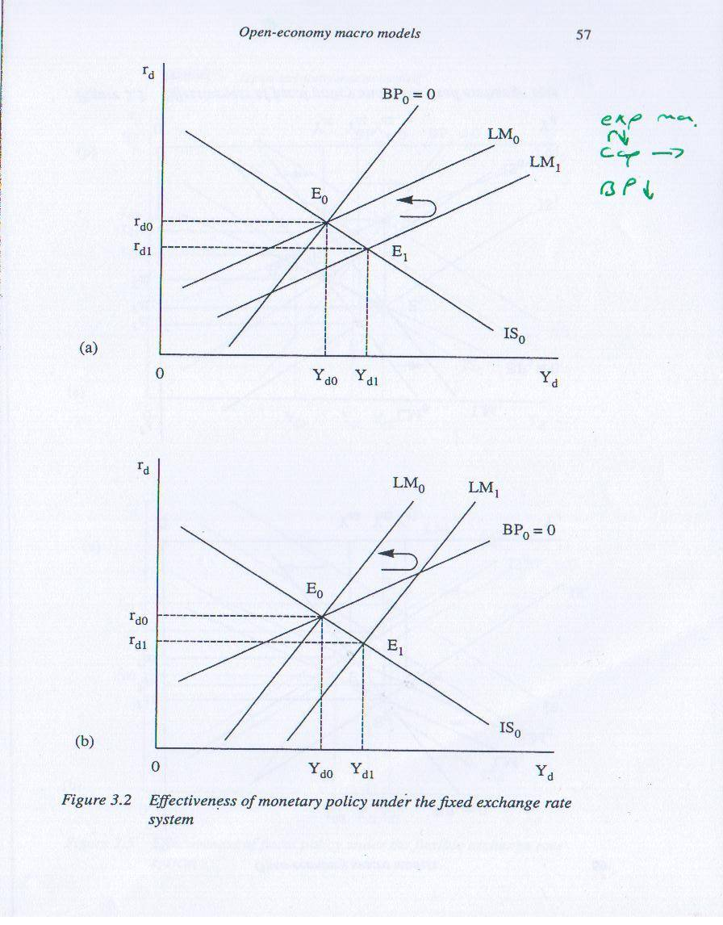

**Fiscal Policy under Fixed Exchange Rates**

An increase in government spending stimulates aggregate demand resulting in a rise in national income as *the IS curve shifts to the right*. To keep things simple, we again assume that both current and financial accounts are initially balanced at point a. The **increase in income has two effects:**

1. It increases the demand for imports; this leads to a **deterioration in the balance of trade and consequently in the current account.**
2. It raises the transactions demand for money; this constitutes a movement along the LM curve. Any increase in money demand, while money supply remains constant, raises the interest rate to keep the money market in equilibrium. The **increase in the interest rate then generates capital inflows so the financial account improves.**

### Fiscal Policy, Fixed Exchange Rates, and Low Capital Mobility

In countries with low degrees of capital mobility, the increase in the interest rate due to the increase in government spending generates only modest capital inflows. Figure 2, where the *BP curve is steeper than the LM curve*, illustrates this case. The increase in government spending shifts the IS curve to the right and the new equilibrium of the goods and money markets occurs at point b. Point b lies below and to the right of the BP curve in the area where *BP<*0*.* Due to numerous capital controls, the trickle of capital inflows (creating a financial account surplus) is insufficient to finance and offset the current account deficit. Thus the balance of payments slips into deficit (*BP<*0), causing excess demand for the foreign currency.

With excess demand for the foreign currency, there is pressure on the domestic currency to depreciate. The only way for the central bank to prevent the depreciation and uphold the fixed exchange rate is to intervene on the foreign exchange market. The central bank must draw on their reserves and sell the foreign currency on the foreign exchange market at the fixed exchange rate. This increases the supply of foreign currency and equilibrates the foreign exchange market again.

Figure 2: Fiscal Expansion under Fixed Exchange Rates and Low Capital Mobility



With low capital mobility, a fiscal expansion generates a balance of payments deficit as the economy moves from point a to point b. It happens because the financial account surplus triggered by higher interest rates is not large enough to offset the current account deficit generated by the increase in income as the economy moves to point b. To preserve a fixed exchange rate, the central bank has to sell foreign currency and the reduction in reserves lowers the money supply. The money supply contracts until the interest rate has risen sufficiently so that the financial account surplus exactly offsets the current account deficit. Note the increase in output from Y0 to Y2: therefore, fiscal policy is somehow effective in raising output under fixed exchange rates with low capital mobility.

The new equilibrium in the goods, money, and external markets at point c does not coincide with the original level of output at point a. Indeed fiscal policy is moderately effective in raising output under fixed exchange rates and low degrees of capital mobility since income increased from Y0 to Y2. We also know that, since we have moved from point a to point c on the *BP=*0 line, the trade deficit has increased (due to a higher level of output Y), and it is now financed by larger capital inflows (the interest rate in c is higher than in a). The capital inflows are thus financing the trade deficit such that ** to restore *BP=*0.

**Fiscal Policy, Fixed Exchange Rates, and High Capital Mobility**

In the case of high capital mobility, *the BP curve is flatter than the LM curve* as shown in Figure 3. An increase in the interest rate due to the increase in government spending generates massive capital inflows in countries with high degrees of capital mobility. The large capital inflows creating financial account surpluses more than compensate for the deficit in the current account at point b, so much so that there exists an overall balance of payments surplus, *BP>*0. The excess supply of the foreign currency exerts downward pressure on the price of the foreign currency. The central bank must therefore intervene to maintain the fixed exchange rate - this time by buying foreign currency in exchange for domestic currency to soak up the excess foreign currency supply. This implies that the domestic foreign reserves increase, in turn triggering a monetary expansion. *The LM curve shifts to the right.*

Figure 3: Fiscal Expansion under Fixed Exchange Rates, and High Capital Mobility

A fiscal expansion shifts out the IS curve and increases income and the interest rate moving the economy from point a to point b. With high capital mobility, the financial account surplus (caused by capital inflows triggered by the higher interest rate) more than offsets the current account deficit (created by the increase in income). To maintain a fixed exchange rate, given the balance of payments surplus, the central bank has to accumulate reserves and the money supply expands to restore equilibrium in the goods, money, and external markets. Under high degrees of capital mobility both, the initial increase in government spending and the ensuing monetary expansion fueled by capital inflows, stimulate the economy resulting in a sizable expansion.



**Fiscal Policy Under the Fixed Exchange Rate System:**

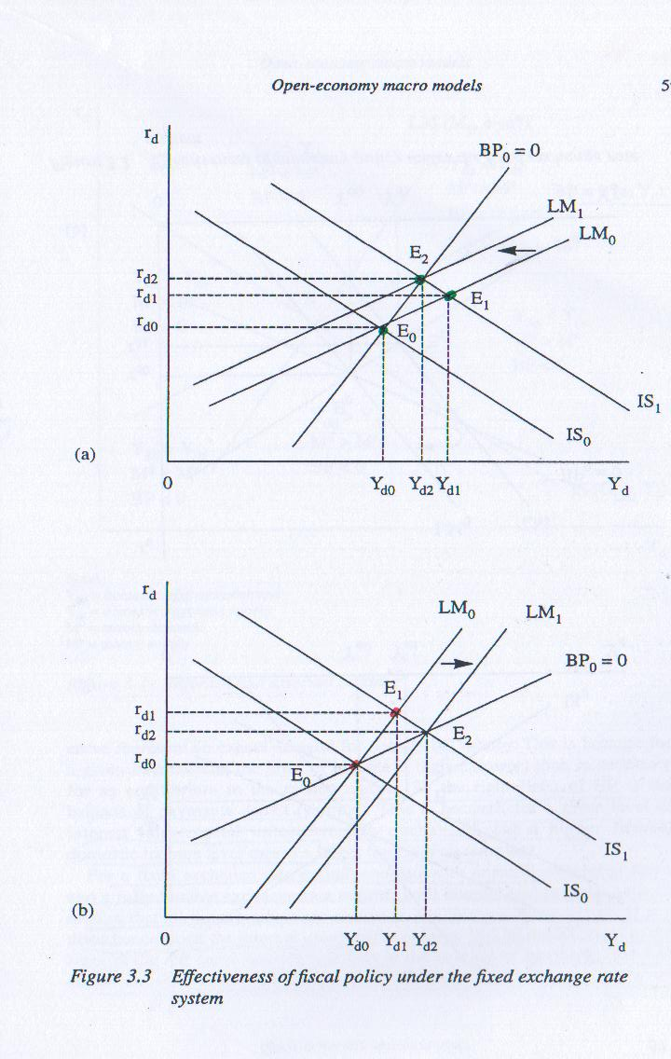

**Exchange Rate Policy**

So far we have considered the impact of monetary and fiscal policy, but there is a third policy that governments can use to stimulate or slow down their economy under fixed exchange rates. The third policy is a devaluation or revaluation of the currency. This is not to say that the government allows the exchange rate to change and float freely. A devaluation or revaluation is simply a statement on the part of the government that instead of holding the price of foreign currency at exchange rate *E0*, it will now hold it at exchange rate . It is a policy because the government changes the peg unilaterally from *E0* to *E1* for a specific reason.

An increase in the price of foreign currency is called a devaluation (more units of domestic currency are necessary to buy one foreign currency unit) and a decrease is a revaluation. A devaluation makes domestic exports more attractive and this is why countries, at times, engage in *competitive devaluations* to protect their domestic producers as well as giving their exporters an edge. A *corrective devaluation* is instead one that aligns the real exchange rate with the nominal exchange rate after periods of high inflation. We consider the economic theory behind these two forms of devaluation within the framework of the Mundell-Fleming model. We also assume that the Marshall-Lerner conditions are met: the devaluation results in an improvement in the balance of trade.

We can also analyze the effect of a devaluation within the Mundell-Fleming framework. We can demonstrate that a devaluation results in a downward shift of the BP curve. Now we add the new concept that, if the economy starts from a *BP=0* equilibrium, the devaluation can only happen it the central bank intervene. The intervention, consisting in an accumulation of foreign reserves (RES increases), causes an increase in the money supply (as the monetary base, MB, increases). So *both the BP and the LM curves shift out* with a devaluation. Figure 4 shows the two shifts.

The devaluation has also a third impact: it improves the current account and stimulates the economy. This is represented by a *rightward shift of the IS curve* as exports increase and imports are discouraged by the higher price of foreign currency. All three shifts result in a new equilibrium corresponding to an economic expansion from Y0 to Y1.

**Figure 4: Economic Effects of A Competitive Devaluation**

**(Starting from a Balance of Payments Equilibrium)**



The competitive devaluation can be achieved only if the central bank buys foreign currency thus increasing the domestic money supply. This raises the price of foreign currency, shifting the external balance, BP, downward while the LM curve shift to the right; the devaluation also causes an expansion in goods exports and a reduction in imports to shift out the IS curve.

**Devaluation Under the Fixed Exchange Rate System:**

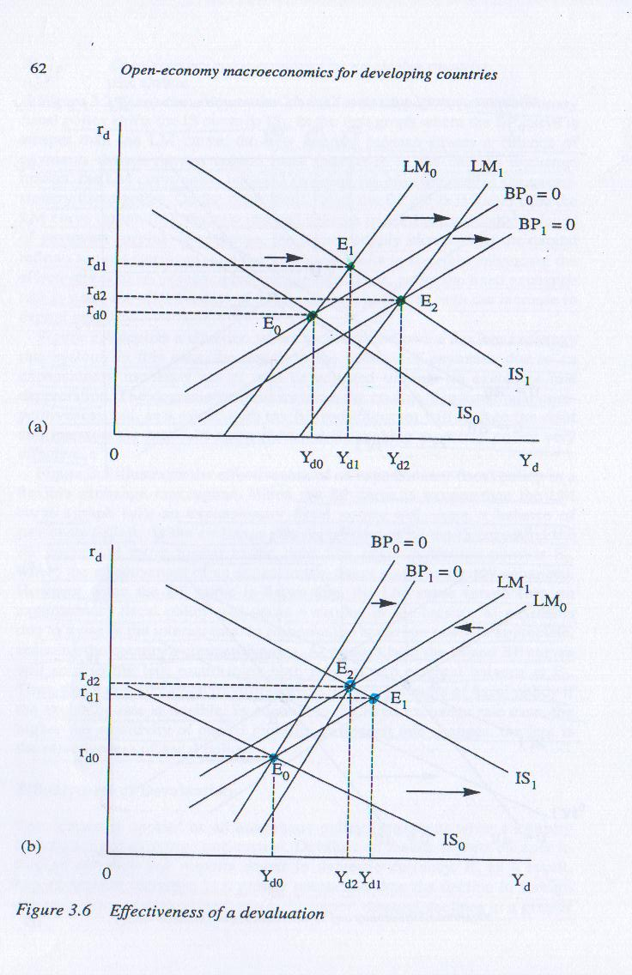

## Monetary Policy under Flexible Exchange Rates

In the discussion below, the goods and money markets are initially in equilibrium where *BP=0.* In fact, with flexible exchange rates, the goods and money market equilibrium (i.e. the IS and LM intersection) always corresponds to external balance, since the exchange rate adjusts continuously to insure that there is no excess demand for foreign currency, i.e. *BP=0* at all time.

An increase in the money supply lowers the interest rate, as represented by the *rightward shift of the LM curve*. The drop in the interest rate then has two effects:

1. Income increases because capital investment is stimulated by the lower interest rates. This increase in income raises imports, affecting the current account negatively and thus causing deterioration in the balance of payments.
2. Financial capital flows out of the country because the return on portfolio investment becomes greater abroad as the domestic interest rate falls. Note that the greater the degree of capital mobility, the larger the capital outflows. Capital outflows also cause deterioration in the balance of payments

As both, the current account and the financial account, decline, the balance of payments originally in equilibrium, *BP=0*, must also turn negative. This balance of payments deficit sets in motion an adjustment in the financial market and in the goods market:

1. A balance of payment deficit generates excess supply of domestic currency. Under fixed exchange rates the central bank intervenes to offset this excess demand for foreign currency. Under flexible exchange rates, however, the central bank does not intervene in the foreign exchange market; market forces (supply and demand) determine a new price of foreign currency. Excess demand for foreign currency results in an increase in its price: the domestic currency thus depreciates. Recall from Chapter 17 that a depreciation of the domestic currency *shifts the BP line to the right.*
2. The depreciation improves the current account, since exports become cheaper to foreigners and imports become relatively more expensive for domestic consumers. This translates into greater activity in the domestic goods market. Domestic consumers purchase more domestic goods because they have become relatively cheaper and, for the same reason, foreigners also demand more domestically produced goods. This triggers an increase in the demand for domestic goods and the *IS curve shifts out to the right*.

The extent of the IS shift depends on the magnitude of the current account improvement resulting from the depreciation. The scale of the depreciation depends on the magnitude of the balance of payments imbalance, thus on the volume of financial capital outflows. Therefore, we can state that the larger the capital outflows, the more dramatic is the deterioration of the balance of payments, causing a greater depreciation, and a larger shift in the IS curve. Since capital flows seem to be a crucial tenet, we must again examine the effects of different degrees of capital mobility on the effectiveness of monetary policy.

**Monetary Policy, Flexible Exchange Rates, and Low Capital Mobility**

Initially, the economy is in equilibrium at point a, the intersection of the IS-LM-BP curves (Figure 5). The monetary expansion shifts LM out to the right, resulting in a higher level of output and a lower rate of interest. Both the current and financial accounts deteriorate causing an unambiguous deterioration of the balance of payments. Under low degrees of capital mobility, these deficits are relatively small because little financial capital can escape the economy – the capital outflows are small. The currency depreciates a bit to restore the external balance and the BP curve thus shifts to the right. As the exchange rate depreciates, the balance of trade improves and IS shifts concurrently to the right. In sum, the two curves, BP and IS, shift together to the right as the exchange rate depreciates until the economy is in equilibrium again with *BP=0* happening at a higher level of income at c.

The monetary expansion under low degrees of capital mobility therefore shifts the output from point a to point b where both the current account and the financial account have deteriorated. The necessary depreciation is sufficiently large so that the ensuing improvement in the current account compensates for the capital outflows (the deterioration in the financial account). With low capital mobility, the extent of the needed depreciation does not have to be that large to restore equilibrium in the balance of payments so IS does not shift that much to reach the new equilibrium point c where *BP=0*: expansionary monetary policy generates a limited expansion. This is better than no impact: the outcome of expansionary monetary policy under fixed exchange rates with non-sterilization.

**Figure 5: Monetary Policy under Flexible Exchange Rates and Low Capital Mobility**



Expansionary monetary policy shifts LM to LM’. The economy moves to a higher level of income and a lower interest rate at point b. The higher income causes a current account deficit and the lower interest rate triggers capital outflows, resulting in *BP<0*. Excess demand for foreign assets and foreign goods generates excess demand for the foreign currency, raising its price. This depreciation of the domestic currency shifts the BP curve to the right and improves the balance of trade triggering an expansion that shifts the IS curve to the right too. These effects will happen until the economy regains its external balance, i.e. until the new IS’ and LM’ curves intersect at a point c where *BP=0* on a new BP’ curve*.*

**Monetary Policy, Flexible Exchange Rates, and High Capital Mobility**

Under high degrees of capital mobility, the lower interest rate caused by a monetary expansion triggers larger capital outflows and therefore a larger balance of payments deficit at point b. A larger depreciation is needed to restore the equilibrium on the foreign exchange market. This implies a larger shift of the IS curve since demand for domestic goods increases even more. The greater increase in the demand for goods generates greater expansion in output. In Figure 6, we show exactly the same IS-LM curves and the same monetary expansion as in Figure 5 sending the economy to the same point b.

However, in the case of higher capital mobility, the depreciation needed to restore the external balance must be greater, because it must generate a greater current account surplus to compensate for the more extensive capital outflows affecting the financial account. The original expansion due to the increase in the money supply (the shift of LM) is the same in both cases as the economy moves from point a to point b. However the expansion resulting from the depreciation (i.e., the move from b to c) is larger in the case of high capital mobility. Therefore, under flexible exchange rates, higher degree of capital mobility enhances the impact of monetary policy on output.

**Figure 6: Monetary Policy under Flexible Exchange Rates and High Capital Mobility**

****With higher degrees of capital mobility, the BP curve is flatter than the LM curve. The original monetary expansion sends the economy to b, but the adjustment on the foreign exchange market needs be greater to compensate for the greater capital outflows. A larger depreciation generates more expansion and the economy moves to c. When comparing the two graphs 19.1 and 19.2, one can see that the movement from a to b is exactly the same, but c is farther to the right in this graph as IS shifted farther out.

**Monetary Policy Under the Flexible Exchange Rate System**

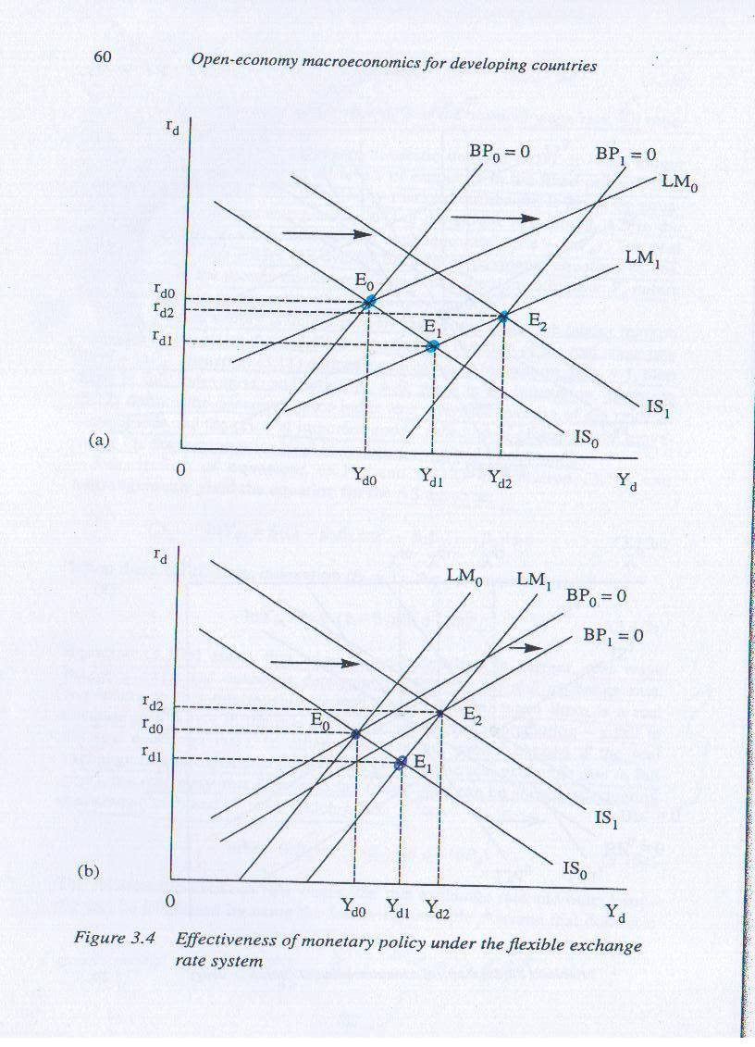

## Fiscal Policy under Flexible Exchange Rates

An increase in government spending raises income and *shifts the IS curve to the right* as shown in Figure 7. This increase in income raises the transactions demand for money, driving up the interest rate. In addition, the increase in income stimulates the demand for imports, causing the current account to deteriorate. Finally, the higher interest rate generates capital inflows.

The crucial question is what happens to the balance of payments. If it improves, the domestic currency will appreciate; if it declines, the domestic currency will loose in value. Whether the balance of payments improves or declines depends on the relative magnitudes of the changes in the current and financial accounts. We encountered the same question in the case of fiscal policy with fixed exchange rates in Chapter 18. Again we must analyze the forces that determine these relative magnitudes to find out whether capital flows offset the changes in the trade imbalance or not. We therefore discuss again the same three cases, representing different levels of capital mobility.

**Fiscal Policy, Flexible Exchange Rates, and Low Capital Mobility**

If the increase in the interest rate generates only modest capital inflows: these inflows are insufficient to finance the current account deficit. As a result, the balance of payments deteriorates; there is excess demand for foreign currency, and, in the absence of central bank intervention, the price of the foreign currency rises: the domestic currency depreciates. The depreciation *shifts the BP to the right* and the goods market improves also, since the depreciation improves net exports. Therefore, *the IS curve shifts again rightward* along with the external balance line, BP, until a new equilibrium is reached where IS-LM-BP intersect.

Figure 7 shows this adjustment, highlighting that the IS curve shifts out not just once, but twice, in the same direction: the first shift is due to the expansionary fiscal policy, and the second shift is due to the improvement in the trade deficit brought about by the depreciation. Note that the lower the degree of capital mobility, the greater is the depreciation required to restore equilibrium in the balance of payments.

**Figure 7: Fiscal Policy under Flexible Exchange Rates and**

**Low Capital Mobility**



Initially, the expansionary fiscal policy sends the IS curve to IS’. The new equilibrium of the economy (IS-LM) at b corresponds to a deficit in the balance of payments (it is below the original BP curve) because the improvement in the financial account is not sufficient to offset the deterioration in the current account. A depreciation will take place to restore the external balance. As usual, the depreciation involves an improvement in the current account so both the BP and the IS curves shift to the right until they both intersect on the LM curve at c where the financial, goods, and currency markets are in equilibrium. Note that the LM curve stays put while the IS curve shifts twice.

Under flexible exchange rates and low capital mobility, the expansionary impact of fiscal policy is therefore enhanced by a subsequent depreciation. Under fixed exchange rates, the impact of expansionary fiscal policy increased with capital mobility; in the next section, we examine whether this is also the case under flexible exchange rates.

**Fiscal Policy, Flexible Exchange Rates, and High Capital Mobility**

When capital flows are highly sensitive to domestic interest rate movements, the capital inflows caused by a fiscal expansion can be huge. With high capital mobility, these capital inflows are larger than the deterioration in the current account: the overall impact results in a balance of payments surplus (the new equilibrium of the economy at point b is above the original BP curve, so *BP>0*).[1] With a balance of payments surplus, there is excess demand for the domestic currency and excess supply for foreign currency as investors shift their financial assets into the domestic economy, selling their foreign currency investment. This drives down the price of foreign currency: the domestic currency appreciates.

The appreciation of the domestic currency *shifts the BP and the IS curves back* (to be precise, the IS shifts southwest and the BP northwest). The IS shifts back because the appreciation hurts domestic exports and creates a flood of foreign imports, reducing the amount of goods produced at home. The new equilibrium is achieved at point c; the appreciation has wiped away part of the improvement in income initially achieved by the increase in government spending.

**Figure 8: Fiscal Policy under Flexible Exchange Rates and**

**High Capital Mobility**



Expansionary fiscal policy shifts the IS to IS’ and the economy moves from a to b. Point b is above the BP line and corresponds to *BP>0*: at b, the capital inflows induced by the increase in the interest rate more than compensate the deterioration in the balance of trade. The external balance is in disequilibrium causing an appreciation that shifts the BP curve to the left (northwest). The increase in the value of the domestic currency has adverse effects on trade: the IS shifts back wiping away part of the fiscal expansion. A new IS-LM-BP equilibrium is reached in c. In this case, IS also shifts twice, but in opposite direction.

It has become clear that increases in the degree of capital mobility have undesirable effects on the effectiveness of fiscal policy with flexible exchange rates. The ensuing appreciation of the currency has a negative impact on the current account leading to a reduction in output. Although the expansion is not as large as with low capital mobility, some expansion still take place. The next query then is whether fiscal policy has any effect under perfect capital mobility.

**Fiscal Policy Under the Flexible Exchange Rate System**

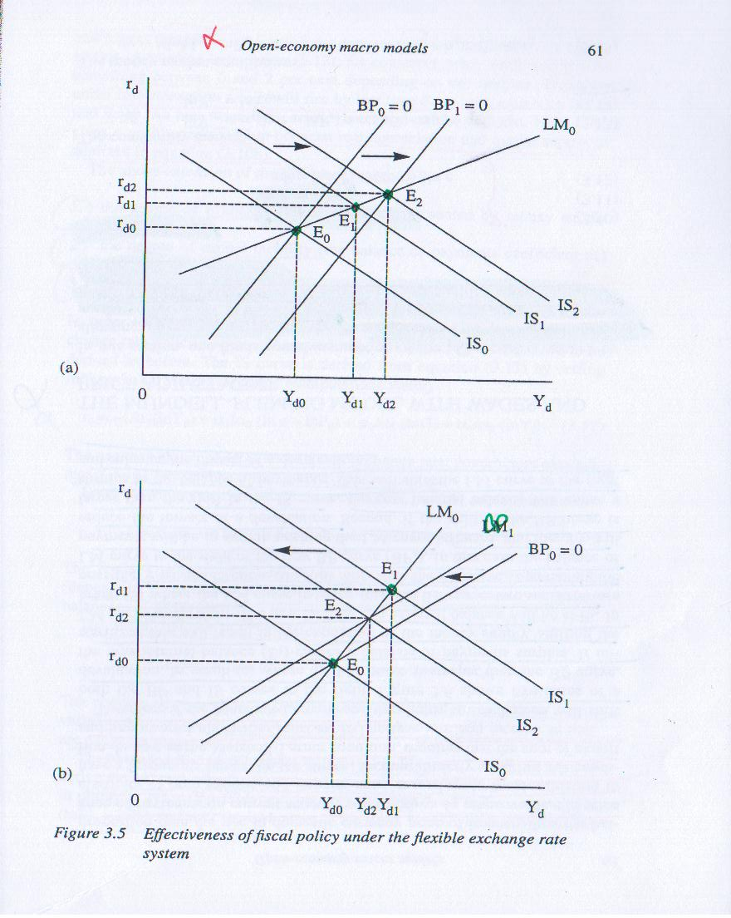

1. Again this happens because we depict high capital mobility as a situation where BP is flatter than LM.